

**Faculty of Engineering, Environment and Computing**

**7089 CEM: Introduction to Statistical Methods for**

**Data Science**

**Assignment Brief [TBA]**

|  |  |  |  |  |
| --- | --- | --- | --- | --- |
| **Module Title**  Introduction to Statistical Methods for Data Science | Individual | | **Cohort:** March 2025 | **Module Code**  7089 CEM |
| Coursework Title  Modeling Power Plant Energy Output Using Nonlinear Regression | | | | **Hand out date:**  TBA |
| Lecturer  Hikmat Saud | | | | **Due date and time:**  TBA |
| **Estimated Time (hrs.):** 4 weeks  Word Limit*: 3000- 4000 | | **Coursework type:**  Individual assignment | | **% of Module Mark:** 100% |
| * Submission arrangement: Online via SchoolWorkshop pro: <https://schoolworkspro.com>. * File types and method of recording: Report (Word), Programme code (R, or Python/Matlab script) * Mark and Feedback date: 2 weeks after submission * Mark and Feedback method (e.g. in lecture): provided in SchoolWorkshop pro. | | | | |

|  |
| --- |
| Module Learning Outcomes Assessed:   * Demonstrate knowledge of underlying concepts in probability and statistics used in Data Science. * Select and apply appropriate statistical methods or techniques to solve problems or analyze data sets. * Use modern software to solve real world problems and analyze large data sets. * Interpret the results of their analyses and communicate those results accurately. |

|  |
| --- |
| Task and Mark distribution:  **Coursework Description:**  The aim of this assignment is to select the best regression model (from a candidate set of nonlinear regression models) that can effectively describe the relationship between several continuous environmental variables and the net hourly electrical energy output (x5) of a Combined Cycle Power Plant (CCPP). Understanding this relationship is crucial for optimizing energy generation, improving efficiency, and managing operational constraints in power plants.  Dataset Description  The dataset contains 9568 data points collected from a Combined Cycle Power Plant operating at full load over a period of six years (2006-2011). The dataset consists of one dependent variable (x5) representing the net hourly electrical energy output and four independent variables (x1 to x4) representing different environmental factors that influence power plant operations.  X2: Net hourly electrical energy output (EP) in MW (dependent variable)  x1: Temperature (T) – Ambient temperature (°C)  x3: Ambient Pressure (AP) – Atmospheric pressure (millibar)  x4: Relative Humidity (RH) – Humidity level (%)  x5: Exhaust Vacuum (V) – Vacuum collected from the steam turbine (cm Hg)  These independent variables are subject to additive noise, assumed to follow an independent and identically distributed (i.i.d) Gaussian distribution with zero mean and unknown variance.  In a Combined Cycle Power Plant (CCPP), electricity is generated by a combination of Gas Turbines (GT) and Steam Turbines (ST), where waste heat from the gas turbine is utilized to power the steam turbine, increasing overall efficiency. The variables in the dataset impact different components of the power generation cycle:  x1, x2, and x3 influence the Gas Turbine’s performance  x4 (Vacuum) affects the Steam Turbine’s efficiency  Experimental Setup & Data Format  To facilitate comparability with previous studies, the dataset has been shuffled five times to allow 5x2-fold cross-validation (CV). Each shuffle undergoes 2-fold CV, generating 10 performance measurements for statistical evaluation.  The dataset is available in three different file formats:  **dataset.csv**  Task 1: Preliminary data analysis:  You should first perform an initial exploratory data analysis, by investigating:  • Time series plots (of input and output signal)  • Distribution for each signal  • Correlation and scatter plots (between different combination of input and output signals) to examine their dependencies  Task 2: Regression – modelling the relationship between gene expression  We would like to determine a suitable mathematical model in explaining the relationship between the output Net hourly electrical energy (y) = x2 with other input x2: Net hourly electrical energy output (EP) in MW (dependent variable), x1: Temperature (T) – Ambient temperature (°C), x3: Ambient Pressure (AP) – Atmospheric pressure (millibar), x4: Relative Humidity (RH) – Humidity level (%), x5: Exhaust Vacuum (V) – Vacuum collected from the steam turbine (cm Hg) that ‘regulate’ its expression, which we assume can be described by a polynomial regression model. Below are 5 candidate nonlinear polynomial regression models, and only one of them can ‘truly’ describe such a relationship? The objective is to identify this ‘true’ model from those candidate models following Tasks 2.1 – 2.6.  To accomplish these objectives, understanding the interconnection between different variable is crucial, which can be achieved through modeling and analyzing provided data.  Data sets: Provided in <https://schoolworkspro.com>. |

Candidate models are with the following structures:

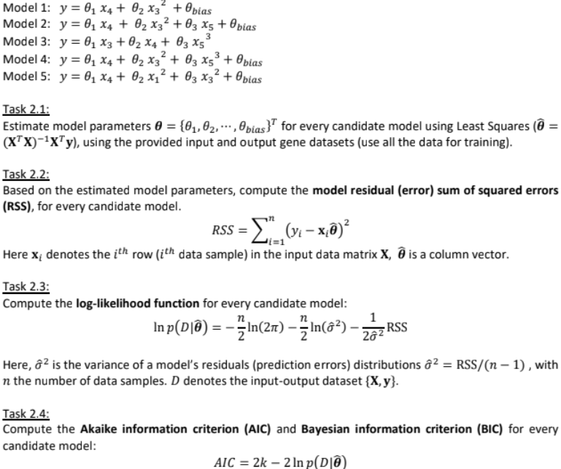



|  |
| --- |
| Task 2.5:  Check the distribution of model prediction errors (residuals) for each candidate model. Plot the error distributions and evaluate if those distributions are close to Normal/Gaussian (as the output variable (x5) is subject to additive Gaussian noise), e.g., by using Q-Q plot.  Task 2.6:  Select ‘best’ regression model according to the AIC, BIC and distribution of model residuals from the 5 candidate models and explain why you would like to choose this specific model.  Task 2.7:  Split the input and output dataset (**X** and **y**) into two parts: one part used to train the model, the other used for testing (e.g. 70% for training, 30% for testing). For the selected ‘best’ model, 1) estimate model parameters use the training dataset; 2) compute the model’s output/prediction on the testing data; and 3) also compute the 95% (model prediction) confidence intervals and plot them (with error bars) together with the model prediction, as well as the testing data samples.  Task 3: Approximate Bayesian Computation (ABC)  Using ‘rejection ABC’ method to compute the posterior distributions of the ‘selected’ regression model parameters in Task 2.  1) You only need to compute 2 parameter posterior distributions -- *the 2 parameters with largest absolute value in* your least squares estimation (Task 2.1) of the selected model. Fix all the other parameters in your model as constant, by using the estimated values from Task 2.1.  2) Use a Uniform distribution as prior, around the estimated parameter values for those 2 parameters (from Task 2.1). You will need to determine the range of the prior distribution. 3) Draw samples from the above Uniform prior and perform rejection ABC for those 2 parameters. 4) Plot the joint and marginal posterior distribution for those 2 parameters.  5) Explain your results.  **Marking Scheme**  This coursework is worth 15 credits (100%). This will be marked according to:  • 20% will be given for performing  Task 1: Preliminary data analysis (histogram plots, simple input output correlation measures, time series plots, fitting linear model,). If you create any programming code, you must include this in the report.  • 40% will be given for performing  Task 2: Regression: Task 2.1 – Task 2.6, 5% each; Task 2.7 has 10%. • 20% will be given to perform the rejection Approximate Bayesian computation (ABC) to compute the (approximated) posterior distribution of the regression model parameters.  • 10% will be given to appropriate discussion and interpretation of the results you obtained. |

|  |
| --- |
| • 10% will be awarded for writing the report (around 3000-4000 words) in a structured, readable form and submitting the executable R scripts. The report should be in sections with appropriate headings, and should include introduction, results, discussion and conclusion sections.  • All your programming code should be included in the Appendix of your report. Please display them in a structured way (put headings like Task 1, Task 2.3, etc.), with appropriate comments/annotations. You need to attach the original R code (or Python/Matlab), **NOT** the screenshots of the code. The code will be marked as part of the above marking scheme (for all the Tasks in this coursework, you will need to provide the corresponding code; when you describe/discuss the Tasks in the main text of the report, please reference the corresponding code section in the Appendix). |
|  |
| Notes:  1. You are expected to use the Coventry University Harvard Referencing Style. For support and advice on this student can contact Centre for Academic Writing (CAW).  2. Please notify your registry course support team and module leader for disability support.  3. Any student requiring an extension or deferral should follow the university process as outlined here.  4. The University cannot take responsibility for any coursework lost or corrupted on disks, laptops or personal computers. Students should therefore regularly back-up any work and are advised to save it on the University system.  5. If there are technical or performance issues that prevent students submitting coursework through the online coursework submission system on the day of a coursework deadline, an appropriate extension to the coursework submission deadline will be agreed. This extension will normally be 24 hours or the next working day if the deadline falls on a Friday or over the weekend period. This will be communicated via your Module Leader.  6. Assignments that are more than 10% over the word limit will result in a deduction of 10% of the mark i.e., a mark of 60% will lead to a reduction of 6% to 54%. The word limit includes quotations, but excludes the bibliography, reference list and tables.  7. You are encouraged to check the originality of your work by using the draft Turnitin links on your Moodle Web.  8. Collusion between students (where sections of your work are similar to the work submitted by other students in this or previous module cohorts) is taken extremely seriously and will be reported to the academic conduct panel. This applies to both coursework and exam answers.  9. A marked difference between your writing style, knowledge and skill level demonstrated in class discussion, any test conditions and that demonstrated in a coursework assignment may result in you having to undertake a Viva Voce in order to prove the coursework assignment is entirely your own work. |

|  |
| --- |
| 10. If you make use of the services of a proof reader in your work you must keep your original version and make it available as a demonstration of your written efforts.  11. You must not submit work for assessment that you have already submitted (partially or in full), either for your current course or for another qualification of this university, unless this is specifically provided for in your assignment brief or specific course or module information. Where earlier work by you is citable, i.e. it has already been published/submitted, you must reference it clearly. Identical pieces of work submitted concurrently will also be considered to be self-plagiarism. |

**Mark allocation guidelines to students:**

|  |  |  |  |  |  |
| --- | --- | --- | --- | --- | --- |
| 0-39 | 40-49 | 50-59 | 60-69 | 70+ | 80+ |
| Work mainly  incomplete  and /or  weaknesses in most areas | Most elements completed;  weaknesses  outweigh  strengths | Most elements are strong,  minor  weaknesses | Strengths in all elements | Most work  exceeds the  standard  expected | All work  substantially exceeds the  standard  expected |

|  |  |  |  |  |
| --- | --- | --- | --- | --- |
| **Marking Rubric**  **Task 1 – Task 3 (80%)** | | | | |
| < 40% | 40-49% | 50-59% | 60-69% | 70+% |
| Little or no implementation of the Tasks using R (or other programming languages) and required approach. Did not describe all the steps in a clear and structured way.  Programming code is only partially or not included in the Appendix. It is not displayed in a structured way with explicit annotations. The code is not referenced appropriately in the main text.  Some or little results are presented quantitatively. A lack of use of figures and tables. | Some implementation of the Tasks using R (or other programming languages), with or without use of  required approach. Partially described the steps of the implementation.  Some programming code is included in the Appendix. It is not displayed in a structured way or without explicit  annotations. The code is not referenced appropriately in the main text.  Some results are presented quantitatively, with or without the use of figures and tables. | Good implementation of the Tasks using required  approach and R (or other programming languages). Describe all the steps in a  clear and structured way. All programming code is included in the Appendix, displayed in a structured way with clear annotations, and is referenced appropriately in the main text.  Results are presented  quantitatively and clearly, with the use of figures and tables. | Very good implementation of the Tasks using required approach and R (or other programming languages). Describe all the steps in a clear and structured way. All programming code is included in the Appendix, displayed in a structured way with very clear annotations, and is referenced  appropriately in the main text.  Results are well presented quantitatively and clearly, with the use of figures and tables. | Excellent implementation of the Tasks using exactly the required approach and R (or other programming  languages). Describe all the steps in a clear and  structured way.  All programming code is included in the Appendix, displayed in a structured way with excellent annotations, and is referenced accurately in the main text.  Results are excellently  presented and evaluated quantitatively, with the use of figures and tables. |
| **Discussion and Interpretation (10%)** | | | | |
| Little or no interpretation of the results; without appropriate discussions and reflections. | Some interpretation of the results, but little in-depth discussions and reflections. | Good interpretation of the results, with appropriate discussions and reflections. | Very good interpretation of the results, with extensive discussions and reflections. | Excellent interpretation of the results, with in-depth discussions and reflections. |
| **Report writing (10%)** | | | | |
| The report is poorly written without a structured, readable format. A lack of clear  presentation and interpretation of figures and tables. | The report is written in a readable format but without a clear structure. A lack of clear presentation and  interpretation of figures and tables. | The report is written in a structured, readable format, with clear display and  interpretation of  figures/tables. | The report is well written in a structured, readable format, with clear display and  interpretation of  figures/tables. | The report has an excellent presentation. It is written in a structured, readable format, with apparent display and interpretation of  figures/tables. |